**HOW TO CREATE WEATHER API KEY**

**COPY** [**https://openweathermap.org/**](https://openweathermap.org/) **THIS LINK AND PAST IN CHROME**

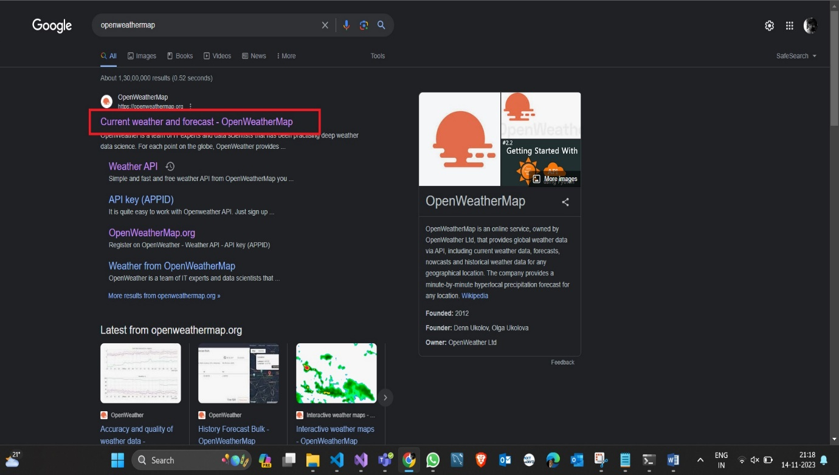

**CLICK ON CURRENT WEATHER AND FORECAST**

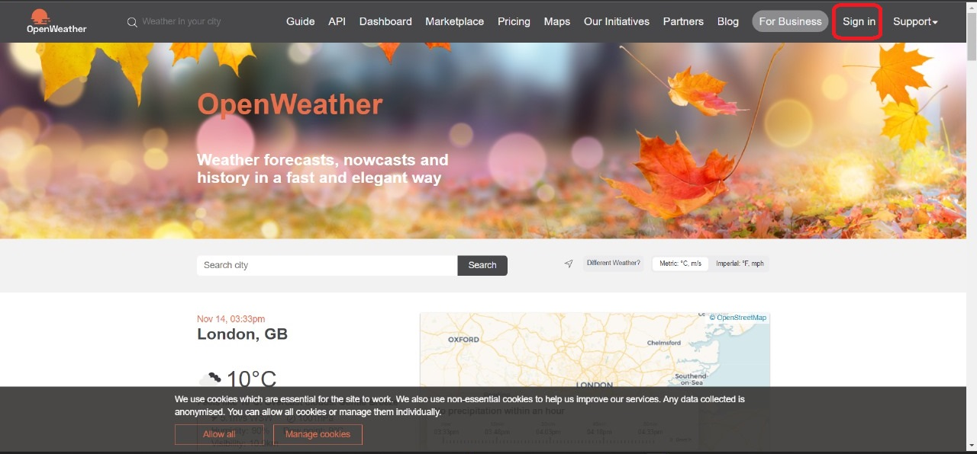

**CLICK ON SIGN IN BUTTON**

**WE NEED TO FILL THE DETAILS AFTER THE SIGN IN TO YOUR ACCOUNT**

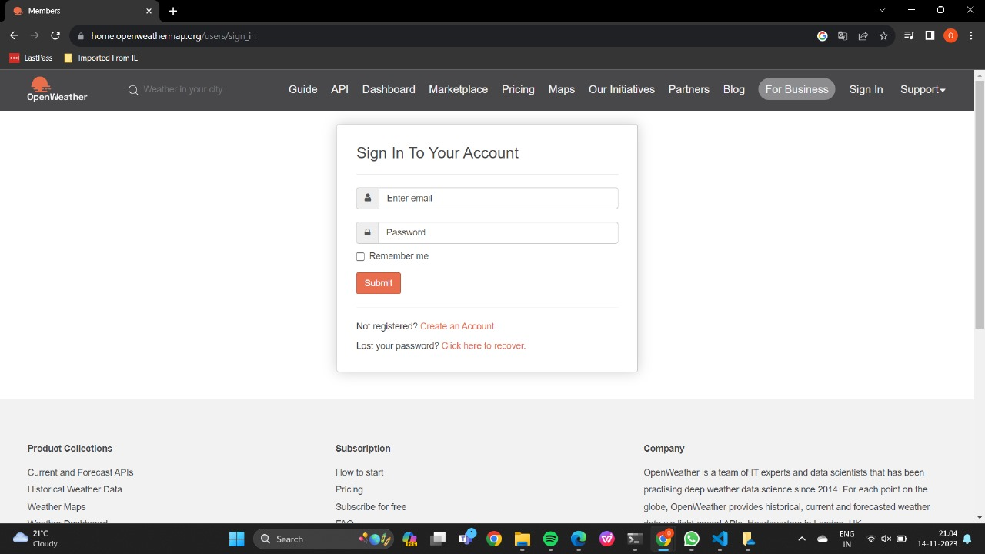

**AFTER SIGN IN NEED TO CLICK ON API KEY**

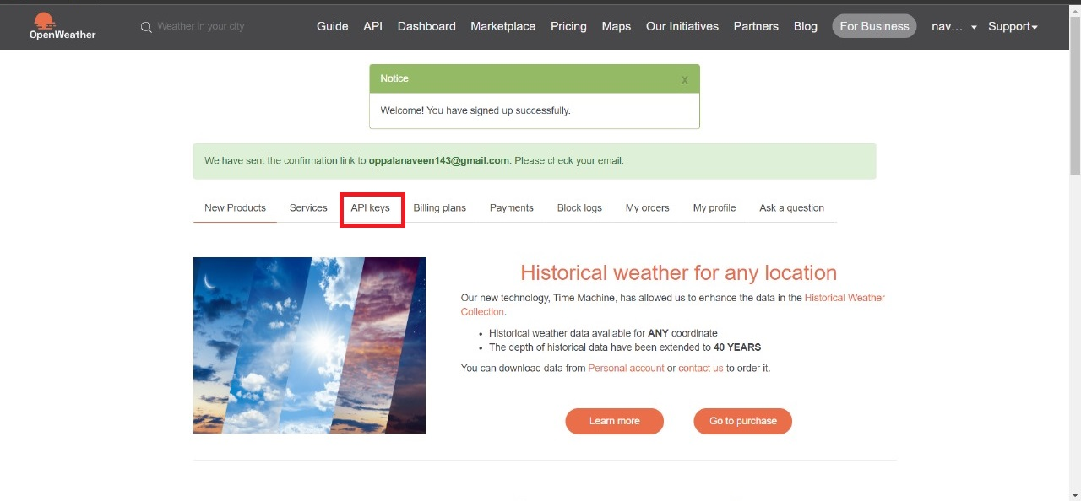

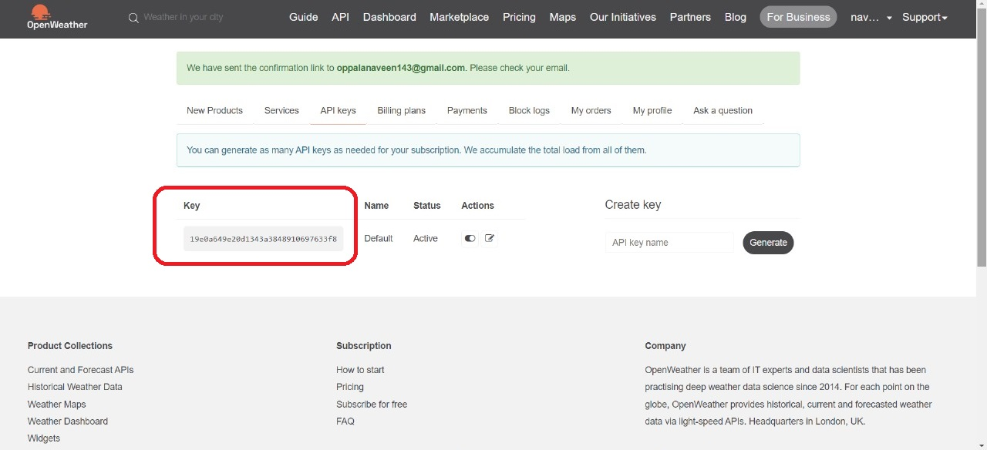

**THE END**